Stability of granular structures of non-convex particles under vibration

It has been established that unconfined, freestanding structures can be built from granular materials. These structures are both sustainable and recyclable, so their study is highly motivated. This project focuses on the response of simple structures, made of granular materials, to vibration. The particles used, mechanically entangle through particle interpenetration and form freestanding columns. The stability of the columns is tested through laboratory vibration experiments.

Particle shape

We chose two different particle shapes: the staples and the S hooks. We 3D printed them, so they are both made of pla and we designed them with the same spatial dimensions to be able to compare them on fair grounds.

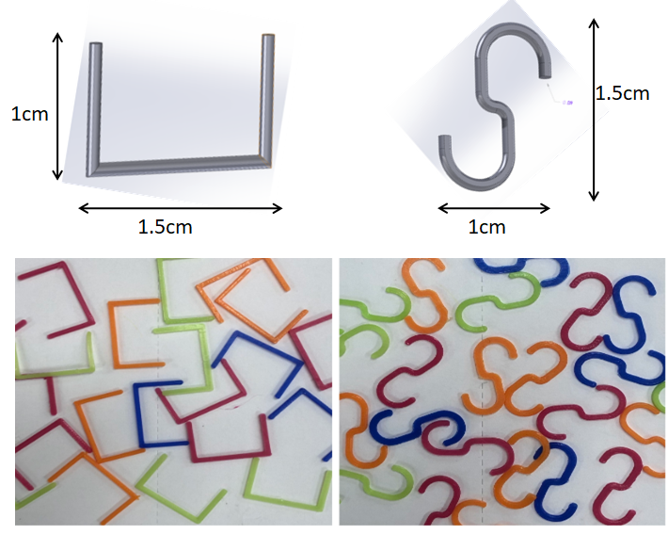

Sample preparation

The general idea of the project was to form cylindrical columns and subject them to vibration tests. The samples were prepared by pouring the particles through a funnel into a cylindrical container of inner diameter 8.6cm, followed by a 60s sinusoidal vibration of the base at a frequency, f=30Hz and peak acceleration Γ=2 in gravitational units, for further compaction, and then remove the cylindrical mold. Approximately, 2900 hooks and 1700 staples were used and the outcome was two columns with the same aspect ratio (same dimensions) and different packing densities.

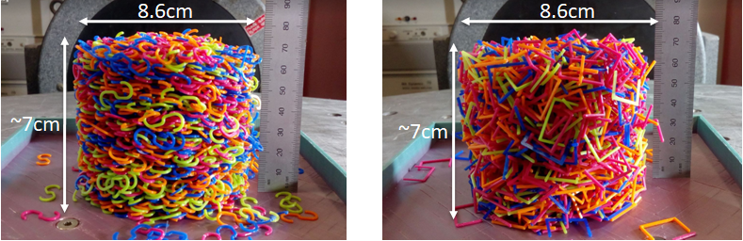

Aspect ratio (d/h) = 1.22857 Aspect ratio (d/h) = 1.22857

Packing density = 0.2351 Packing density = 0.04041

Experimental set up

The columns were placed on the vibration table and subjected to horizontal, sinusoidal vibration. The shaking table was controlled by LabView and the column collapse was monitored using a high-speed camera. The camera was connected to the computer, where all the data were stored. The lighting and the white backround seen in the picture were necessary for the image analysis.

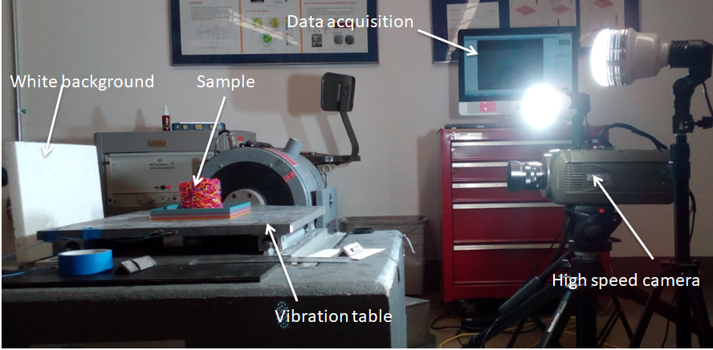

Experimental procedure

We vary the frequency and acceleration of the vibration, forming different combinations and for every combination we measure the height of the center of mass (h(t)) and the area (A(t)) of the column versus time. The vibration is horizontal and sinusoidal and lasts for approximately 130seconds. The chosen frequencies were [20,30,40] Hz and the values of acceleration were [2, 2.8, 3.5], so there were 9 examined combinations. The images taken were analyzed in matlab and the outcome was graphs of normalized height (h(t)/ho) and normalized area (A(t)/Ao) of the column versus time.

General information about the experiments

1st: the base of the sample is not affixed at a specific point on the vibration table, so the column slides during the shaking.

2nd: the 3D printed base for the vibration table has a lip, which covers a small area of the sample. That area was cut during the image analysis, so the final values found might be slightly different than the ones we would find if the whole sample area was examined.

3rd: the entanglement between the hook shaped particles is extremely high so if one particle falls during the vibration it pulls down the rest of them as well, something that is not observed with the staples.

Results

S hooks - constant frequency(f) - varying acceleration(a)

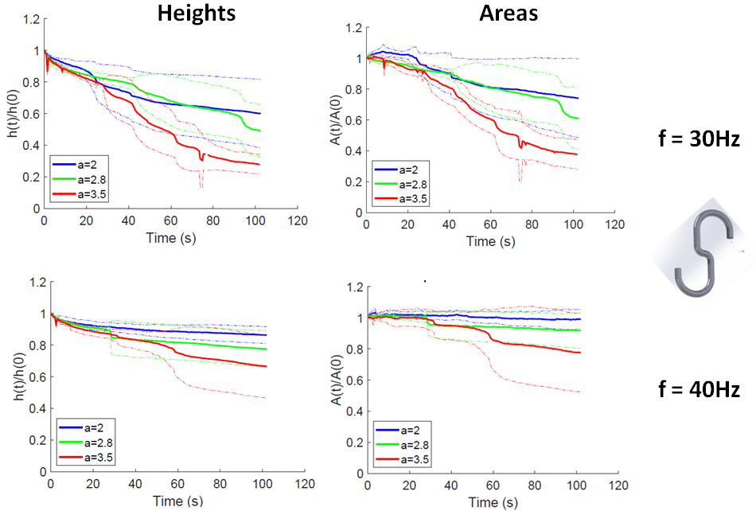

Staples - constant frequency(f) – varying acceleration(a)

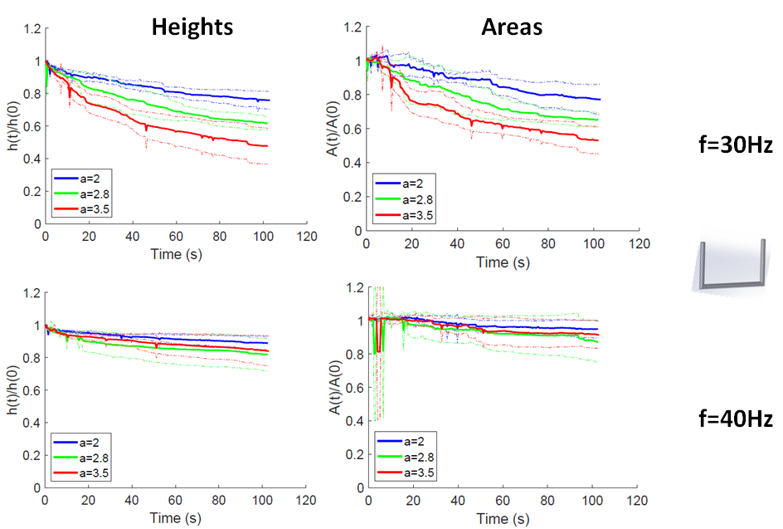

* The thick curves seen in the graphs are the actual results and the thin ones the standard deviation.
* As the acceleration increases so does the deformation
* At the frequency f=40Hz we barely observe deformation
* An initial dilation of the area is observed before the sample eventually compacts

Constant acceleration(a) - varying frequency(f)

Same data set from a different perspective. Same observations.

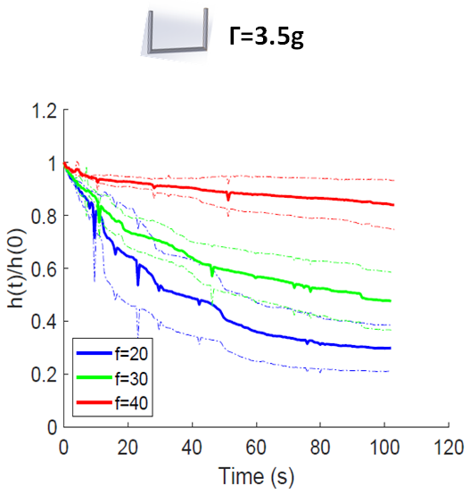 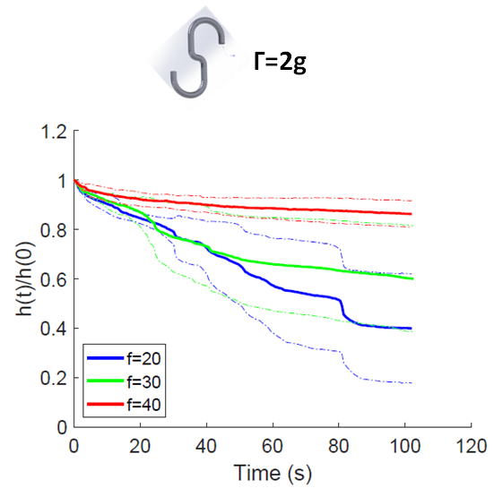

Comparison

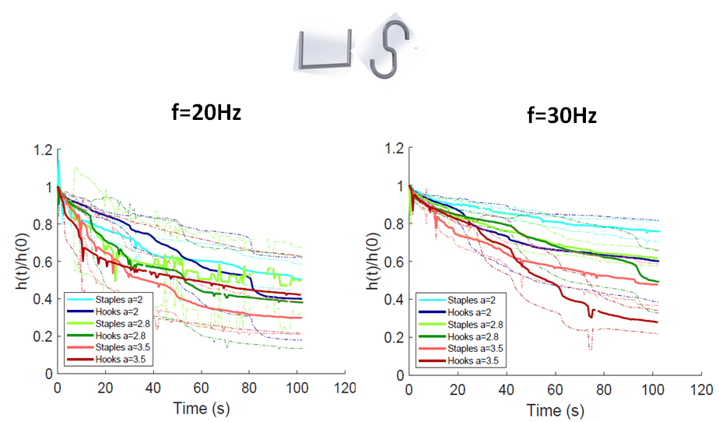

In general, as it was observed in the experiments, the staples appear to be more stable than the S hooks which is also shown in the right graph.

Although, at the frequency f=20Hz the results are a bit confusing.

Possible explanation that the eigen frequency of the sample of the hooks is close to 20Hz

Conclusions

* For both staples and S hooks, at a constant frequency, the deformation increases with the increase of the acceleration
* Possibility of resonance for staples at f=20Hz and for hooks at f=30Hz

No collapse observed at f=40Hz

* Increased interlocking in the case of hooks leads to chain reaction-type collapse